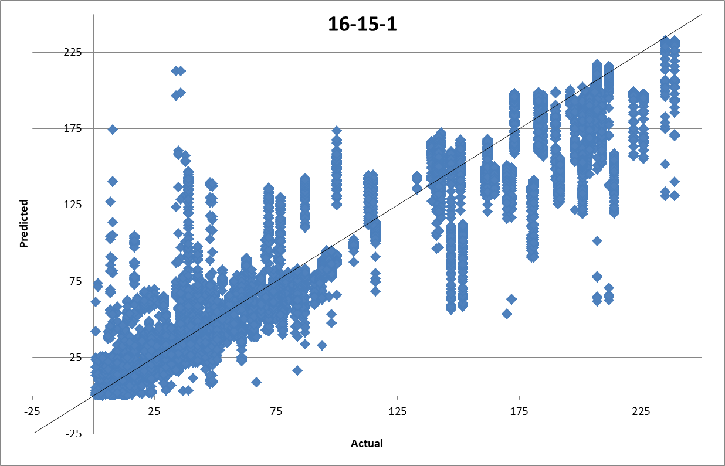

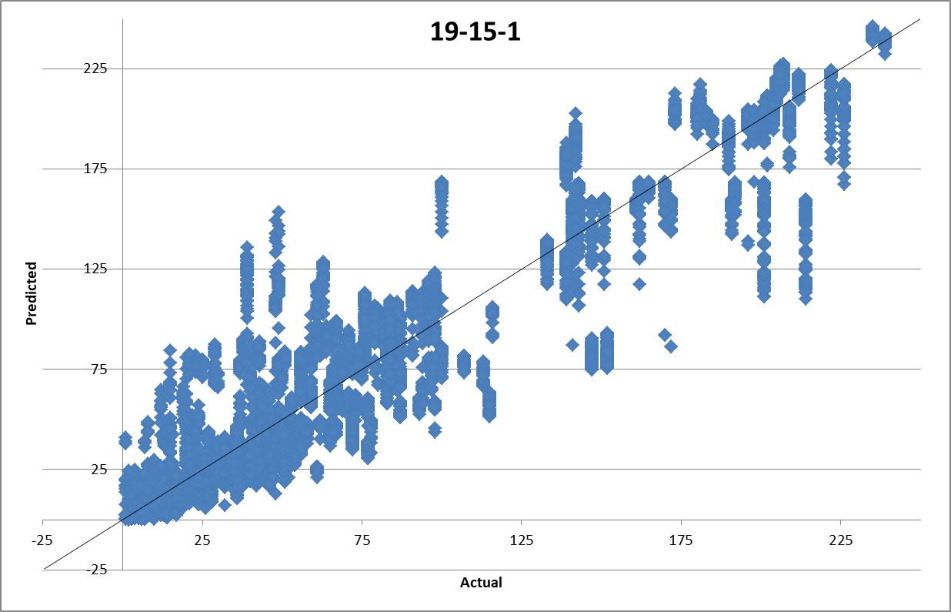

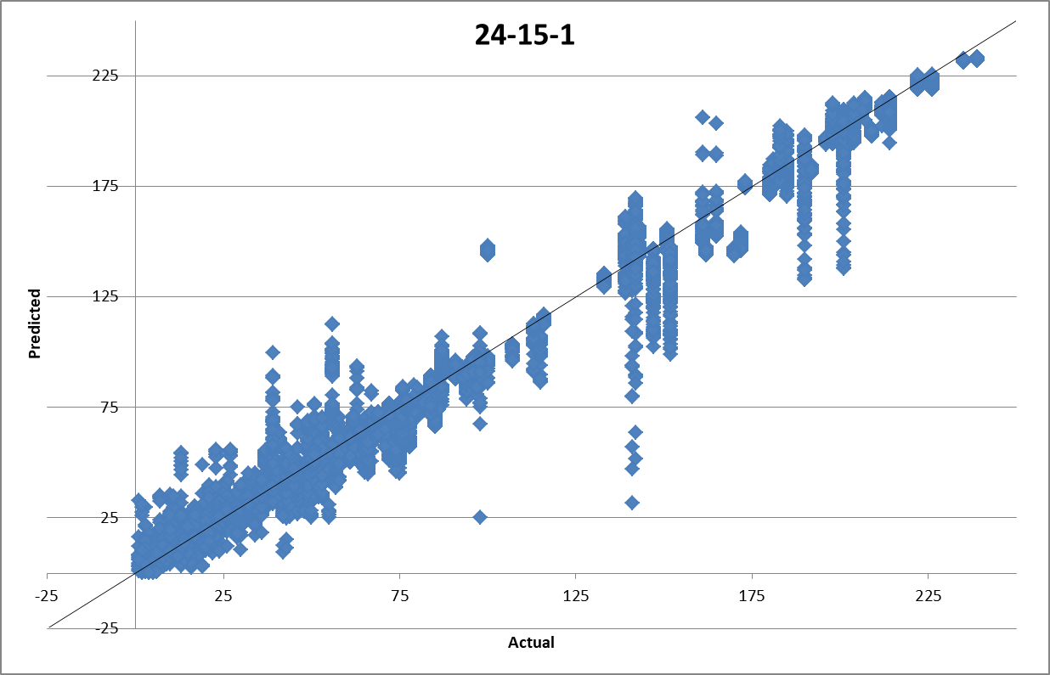

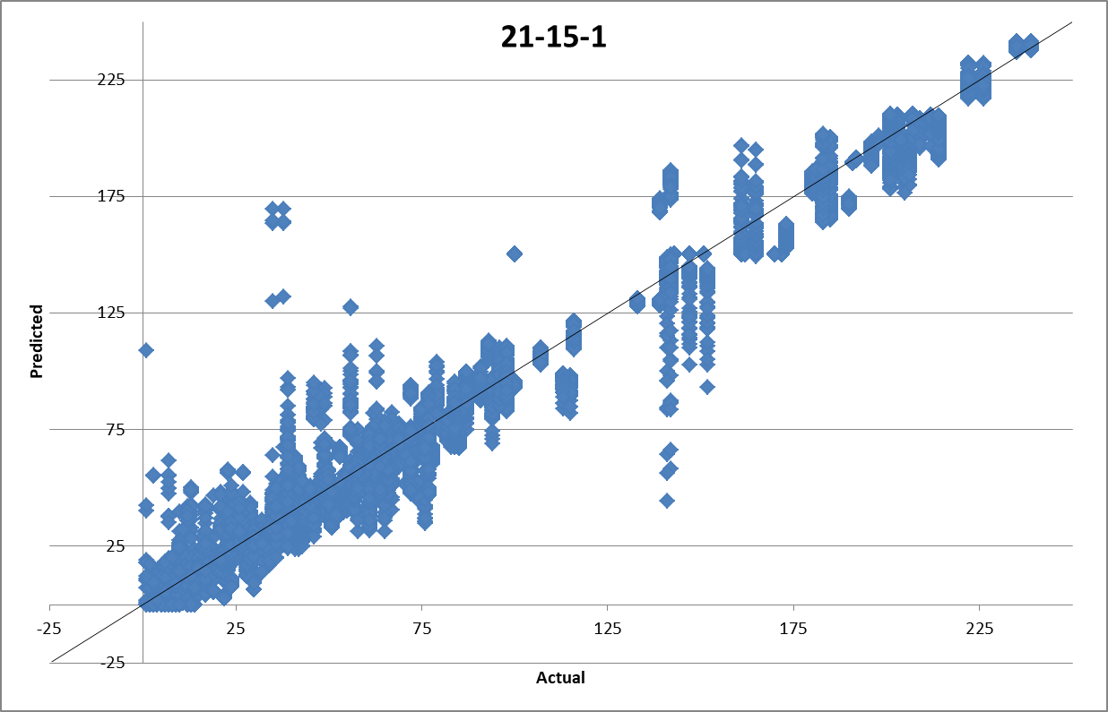

|  |  |  |  |  |
| --- | --- | --- | --- | --- |
|  |  | 6-15-20000 | 5-15-20000 | 8-12-19900 |
| TR | MARE | 31.833 | 30.555 | 32.05 |
| R2 | 0.87513 | 0.87464 | 0.87127 |
| ASE | 0.009466 | 0.009673 | 0.009818 |
| TS | MARE | 31.639 | 29.828 | 31.713 |
| R2 | 0.87272 | 0.87323 | 0.8688 |
| ASE | 0.009615 | 0.009765 | 0.009976 |
| VAL | MARE | 31.884 | 30.408 | 31.932 |
| R2 | 0.86967 | 0.87372 | 0.86465 |
| ASE | 0.009849 | 0.009783 | 0.010308 |
| ALL | MARE | 28.729 | 31.772 | 30.407 |
| R2 | 0.88666 | 0.85759 | 0.87668 |
| ASE | 0.008826 | 0.011864 | 0.010162 |
| FINAL BUILD | **6-15-20000** | | | |
|
| FINAL STRUCTURE | **16-15-1** | | | |
|